1. **General**
2. The e-exam will be conducted during the original scheduled date and time.
3. Students will download the exam paper and upload the answers through LumiNUS Files (see part C).
4. All answers must be handwritten using pen on A4 paper.
5. The duration of the exam is 2 hrs (exclusive of uploading the answers).
6. You will be given 15 minutes after the end of the exam to scan and upload your answers to LumiNUS.
7. The exam is open book but students are not allowed to discuss with one another.
8. The exam will be monitored using Zoom (see part B).
9. You may go for a short toilet break (not more than 5 minutes) during the exam.
10. Students suspected of cheating will be called for interview by examiner.
11. Those who cheat will be subject to disciplinary action. Those who facilitate cheating by others (e.g. providing others with solutions) will also be subject to disciplinary action.
12. Print out the Exam Declaration Form (see last page) in advance. This form is to be signed and submitted together with your answers.
13. **Using Zoom**
14. Join the Zoom conference 15 minutes before the starting time of the exam on 27/04/2021. You are advised to try out Zoom at the Zoom Test site in advance if you’re not familiar with it.
15. You may join the Zoom conference with a laptop equipped with webcam or your mobile device (you need to download the Zoom app).
16. During the exam, you are not allowed to communicate with anyone. You can use the chat function in Zoom if you have a question for the invigilator.
17. 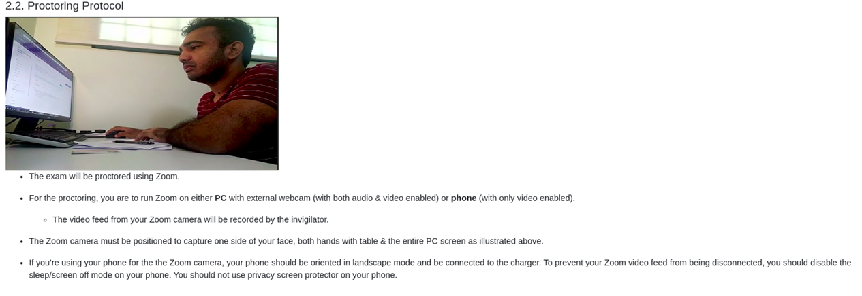The invigilator will make announcement using Zoom during the exam. Do not silence your device (but you may want to turn off other apps that sent you push-notification). Also make sure your zoom audio setting is “mute”.
18. Make sure that the video setting in Zoom is turned on at all times during the exam and adjust your camera such that your face, hands, writing papers and computer screen are visible as shown in the sample photo.

1. **Using LumiNUS**
2. it is advisable that you scan and submit the signed Exam Declaration Form (see last page) in advance to LumiNUS folder.
3. Download the exam paper through LumiNUS > Files > Exam folder (this folder will be opened 27/04/2021 at 16.55 hr).
4. At the end of the exam, give yourself sufficient time to:
5. scan or take pictures of your work (it is your responsibility to make sure the images can be read clearly);
6. merge all your images into one pdf file (arrange them in the order: Q1, Q2, … in their page sequence);
7. name the pdf file by Matric No_Module Code (e.g. **A123456R_MA1234**);
8. upload your pdf into the LumiNUS folder > Files > Exam Submission > Exam group x, where x is your exam group number.

*You are advised to try out scanning apps in advance to find one that you’re comfortable to work with. Some recommendations include:*

* *Scanning app for Android phones:* [*https://fossbytes.com/best-android-scanner-apps/*](https://fossbytes.com/best-android-scanner-apps/)
* *Scanning app for iPhone:* [*https://www.switchingtomac.com/tutorials/ios-tutorials/the-best-ios-scanner-apps-to-scan-documents-images/*](https://www.switchingtomac.com/tutorials/ios-tutorials/the-best-ios-scanner-apps-to-scan-documents-images/)

1. The submission folder will close at 27/04/2021 at 19.15 hr. After the folder is closed, exam answers that are not submitted will not be accepted.
2. If you encounter problems downloading/uploading files through LumiNUS, send a chat message on Zoom to the invigilator and wait for instructions. As a back-up, you may log in to your NUS Email account and email your lecturers Jonathon Teo at [jonathonteo@nus.edu.sg](mailto:jonathonteo@nus.edu.sg), Clifton Ng at [cnwz@nus.edu.sg](mailto:cnwz@nus.edu.sg), or Christian Go at [christian.go@nus.edu.sg](mailto:christian.go@nus.edu.sg).

(Updated 2021.02)

|  |  |  |  |  |
| --- | --- | --- | --- | --- |
| **Exam For:** | **Semester** |  | **AY** |  |
| **Module Code:** |  | | | |

**Please read A, B and C, then sign and submit this declaration form together with your answers.**

1. **Academic, Professional and Personal Integrity**
2. The University is committed to nurturing an environment conducive for the exchange of ideas, advancement of knowledge and intellectual development. Academic honesty and integrity are essential conditions for the pursuit and acquisition of knowledge, and the University expects each student to maintain and uphold the highest standards of integrity and academic honesty at all times.
3. The University takes a strict view of cheating in any form, deceptive fabrication, plagiarism and violation of intellectual property and copyright laws. Any student who is found to have engaged in such misconduct will be subject to disciplinary action by the University.
4. It is important to note that all students share the responsibility of protecting the academic standards and reputation of the University. This responsibility can extend beyond each student’s own conduct, and can include reporting incidents of suspected academic dishonesty through the appropriate channels. Students who have reasonable grounds to suspect academic dishonesty should raise their concerns directly to the relevant Head of Department, Dean of Faculty, Registrar, Vice Provost or Provost.
5. **I have read and understood the rules of the assessments stated below.**
6. Students should attempt the assessments on their own. There should be no discussions or communications, via face to face or communication devices, with any other person during the assessment.
7. Students should not reproduce of any assessment materials, e.g. by photography, videography, screenshots, or copying down of questions, etc.
8. **I understand that by breaching any of the rules above, I would have committed offences under clause 3(l) of the NUS Statute 6, Discipline with Respect to Students which is punishable with disciplinary action under clause 10 or clause 11 of the said statute.**
9. *Any student who is alleged to have committed or attempted to commit, or caused or attempted to cause any other person to commit any of the following offences, may be subject to disciplinary proceedings:*
10. *plagiarism, giving or receiving unauthorised assistance in academic work, or other forms of academic dishonesty.*

**I have read and will abide by the NUS Code of Student Conduct, in particular, A (Academic, Professional and Personal Integrity), B and C when attempting this assessment.**

|  |  |
| --- | --- |
| **Signature:** |  |
| **Full Name:** |  |
| **Student Number:** |  |